README
Software Environment:
Application is developed in the following software environment:
- Development Environment: Microsoft Visual Studio 2012 Ultimate
- Framework: .NET Framework 4.5
- User Interface: Windows Forms
- Programming Language: C#.NET, WCF, Entity Framework
- Data Access: Entity Framework 6.0
- Database: Microsoft SQL Server 2008
- Code Analysis Tool: StyleCop
- Unit Testing Tool: NUnit

Pre-requisite
The following tools need to be installed in your machine to run the application:
Microsoft Visual Studio 2012
Entity Framework
NUnit
NUnit Test Adapter
SQL Server 2008

Project Description:
A Restaurant Service has been developed that exposes business functionalities like PlaceOrder, GetAllOrder, ApproveOrder, DeclineOrder, GetNewOrders, and MarkOrderAsComplete. A Restaurant Service has been developed using C#, WInForms, WCF, Entity Framework and SQL Server 2008 as back-end (Database).WCF Service has been hosted in a console application and it exposes two endpoints for Waiter and Chef Clients respectively.
The application UI comprises of Waiter and Chef Screens. The Waiter UI provides operations viz. selecting the items, placing the orders, delete the orders, and getting all order details.
The Chef UI provides operations viz. showing orders to approve and already approved orders in a descending chronological order by time, approve, mark order as ready, and decline orders respectively. When the chef completes the meal, he can mark the meal as Ready by selecting ‘ORDER READY’ option. The moment meal is ready, a notification is sent to Waiter with all order details like Table Id, Start time, Completion time, Status. Also the completion status is logged to an xml file at location “C:\CustomerOrders_.xml”. To implement notification functionality, used Callback mechanism in WCF. A notification is also sent to Waiter when the Chef declines the order. The Chef client implements timer mechanism that keeps checking for new orders from waiter for every 15 seconds. The service do not delete the completed orders but archives them in database.
Used Entity framework’s Code first approach to create database called ‘RestaurantDB’. It creates three tables viz. CustomerOrders, FoodItems, and ItemOrderXRefs.
CustomerOrder – The data is added to this table when the waiter places an order.
FoodItems – The table contains menu items.
ItemOrderXRefs – The table contains the food items and the quantity for each order.
Added Unit tests using NUnit testing framework covering different scenarios.

Installation:
- Build the entire solution.
- Launch ServiceHost (RestaurantService.Host.exe)
- Launch Waiter UI (RestaurantWaiterClient.exe)
- Launch Chef UI (RestaurantChefClient.exe)

UI Steps
Restaurant Service
The project consists of one service and 2 clients
One client is for the waiter and one is for the chef
User interfaces are provided for both waiter and chef

Waiter Client:
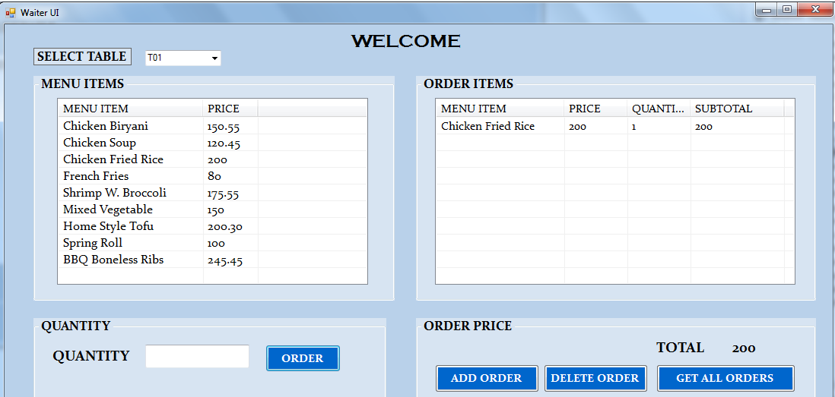
The UI looks as above. The waiter selects a table number from the drop down “SELECT TABLE” and then selects item from the “MENU ITEMS” and enters the quantity in the box provided below.
Based on the selection of the items and the quantity, the “TOTAL” is generated.
“Add Order” sends the order to the Chef Client.
The selected items from the menu can be deleted using the “Delete Order” and order once placed cannot be deleted
“GET ALL ORDERS” shows the list of all orders with their status placed by the waiter.
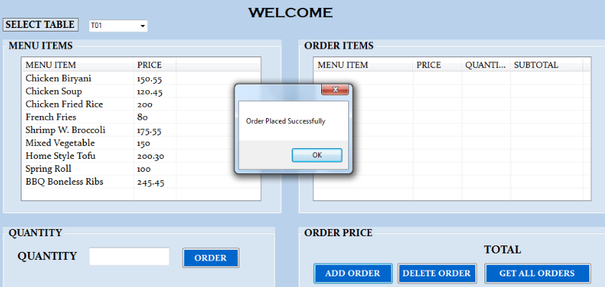
Below are the Exceptions that are handled in Waiter UI:
- Selection of table number/Menu items are mandatory to place an order.
- The quantity can only be non-negative number > 0.
- After performing “ADD ORDER”, the order cannot be deleted.
- “ADD ORDER” can be performed only when there is at least one item selected

Chef Client:
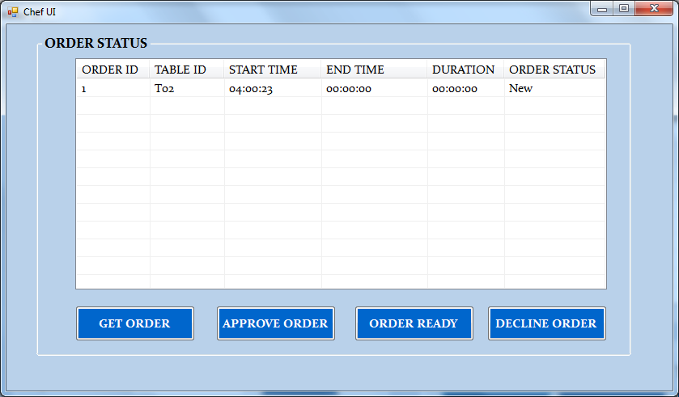
Chef client receives the order sent by Waiter.
Chef can perform operations like Approve order, mark order as complete, get all orders and decline order.
The Chef selects an order and can accept/approve the order by clicking the “APPROVE ORDER” button.
Chef can otherwise deny the order by clicking “DECLINE ORDER” which sends a notification to the waiter client and is removed from the Chef UI.
Once the food is ready the Chef changes the status of the order to Ready by clicking “ORDER READY” which sends a notification to the waiter so that he can collect the order.
The time the order is received has been considered as “START TIME”. Once the Order is marked as ready, the time between the order received and marked as ready “END TIME” is calculated as the “DURATION” that it took for the order to be made ready.
Once the “ORDER READY” is performed the order entry is removed from the Chef UI but is archived in the backend tables. A logging is performed using XML file that logs the time taken for each order.
Exceptions:
- A New order can only be approved or declined. An approved order can be later marked as complete.
- An Approved order cannot be declined but can be marked as complete.

